From the Director

By: Josh Theis, Executive Director

Options learned the sad news that Tom Diedrick passed away in May. Tom was the Executive Director at Options for 37 years. Tom’s advocacy efforts for the disability community are unparalleled and respected throughout Wisconsin. Tom’s leadership led to the construction of the showcase model home, growth of services and the establishment of Options endowment to name just a few. I only got to know Tom over the past year. Tom was an open book for me and would share insight or answer any question I had. Tom’s kindness and unwavering positivity remain part of Options culture today. Part of Tom’s obituary is shared in this newsletter. I encourage you to take a moment to reflect on what Tom has done for the disability community.
As we move into summer, Options is excited to offer more resources and assistance to consumers who are currently living in an institutional setting and want to move back into the community. Utilizing funds from the American Rescue Plan Act, a new Community Transition Nurse will be available for individuals looking to relocate to the community from an assisted living or nursing home. The Community Transition Nurse will be tasked with connecting individuals with the needed support to not only move back to the community but thrive in the community. Assistive technology, independent living skills and access to caregivers are some of the “tools” the community transition nurse will utilize to assist consumers in getting home.
In May Options began partnering with the Micah Center in Green Bay. The Micah Center is a daytime resource center for adult men and women currently experiencing homelessness or at-risk for homelessness in the Green Bay community. Options Certified Peer Specialist began spending dedicated hours at the Micah Center each week. The goal is to help support a person in their journey to self-sufficiency.
This newsletter will provide you with highlights of what’s happening at Options, events and what we are doing in the communities we serve.
Take care and stay healthy,
Josh Theis
Executive Director

Saying Goodbye to a Leader, Advocate, and Friend…

With great sadness Options says goodbye to Tom Diedrick, retired Executive Director of Options. Tom passed away on May 24, due to complications from COVID. Tom was a consummate advocate, leader, and mentor to all who knew him. His caring and compassion for individuals with disabilities and those who were aging shown through in everything he did, personally and professionally. He strived to make communities accessible for all people with disabilities. In 1980, Tom was hired by Options to work as a peer specialist, sharing his personal experience of disability with those newly injured and their families. This position also gave Tom the opportunity to assist individuals who with disabilities to live independently in their respective community.
Tom was appointed Executive Director of Options in 1992, a position he held until his retirement in 2018. As Director, he spearheaded efforts to build a showcase accessible home and office complex in Green Bay to provide independent living services in a unique and unparalleled manner. Tom was instrumental in establishing an Options Endowment Fund and managing two successful Growing Options Campaigns. He worked tirelessly during his 38-year tenure with Options to improve access, reduce barriers and increase opportunities for individuals with disabilities.
In 2013, Tom was awarded the National Council for Independent Living Advocacy Award for his dedication to the disability rights movement. The WI Fair Housing Network presented Tom with the 2018 Special Recognition Fair Housing Award for his outstanding contributions in furthering fair housing in the community. Tom served on the Brown County Aging and Disability Resource Center Board and was a long-time member of the Brown County Housing Authority.

He will be greatly missed by all who worked with him and knew him. Rest well dear friend!

*A Memorial Fund has been established at Options for Independent Living, Tom Diedrick Fund, PO Box 11967, Green Bay WI 54307.

UPCOMING EVENTS

2nd Annual Community Expo on Friday, August 26th at Options for Independent Living, Green Bay
Last year Options hosted a durable medical equipment drive and although we had good attendance, we wanted to make it better this year by adding activities…check it out!
- Durable Medical Equipment (DME)drive – hosted by Options, WISTECH, and the Bureau of Correction. Donate your used walkers, wheelchairs, bath benches, etc. We’d be happy to take it off your hands and get it back to tip top shape so that someone else in need can benefit from its use!

Wheelchair Wash and Safety Check

Hearing Screening

Adaptive Recreation Equipment Demos

Adaptive Vans

Food, Door Prizes, and much more!

Come and join the fun on Friday, August 26 from 10 am – 2 pm at Options, 555 Country Club Road, Green Bay!
If you cannot make it on the 26th and have durable medical equipment you would like to donate we have three other locations and dates where you can drop them off from 10 am – 2 pm. August 16, Marinette County Elderly Services located at 516 N Hwy 141, Crivitz; August 17, Sheboygan County ADRC, 650 Forest Ave, Sheboygan Falls; and August 18, Green Lake Fair Grounds, 570 South St, Green Lake.
* Options is collaborating with WISTECH (WI Assistive Technology) and the Bureau of Corrections at Red Granite for this drive. The items are taken to the Red Granite Corrections Facility and inmates refurbish the equipment giving them skills for when they are released and keeping 100’s of pounds of equipment from our landfills.

Taking Care of Your Mental Health this Summer
By Kristen Fuller, M.D., is a clinical content writer and enjoys writing about evidence-based topics in the cutting-edge world of mental health and addiction medicine. Complete article can be found at https://discoverymood.com/blog/mental-health-during-the-summer/
The warmth, relaxation, and flexibility that the summer months bring can be exciting for vacations and sunshine, but for some, summer months can have the potential to trigger feelings of being overwhelmed and losing control. Expectations of being carefree can put a lot of pressure on those who are struggling with depression or anxiety. Below are self-care tips and tricks that can be used to maintain your mental health during the summer months.
1. Take care of your mental health this summer by getting outside - Exposure to natural sunlight increases levels of vitamin D and serotonin, which are known to boost your mood. Taking a moment to step outdoors or pick up a new outdoor hobby where you can spend 30 minutes in the sunshine.
2. Take time to unwind by using your vacation time - Many of us use paid vacation time to accomplish tasks around the house that we neglect during our busy workweeks. Instead of cleaning out the closet, organizing the garage and attending long-overdue appointments, use your vacation to enjoy yourself.
3. Re-focus your energy by planning a getaway - Getting out of town and experiencing a change in scenery is a great way to unwind and re-focus your energy on the present.
4. Maintain a healthy sleep schedule for mental health - Try to maintain a healthy and steady sleep schedule for yourself and your kids, regardless of work and school schedules. It is recommended that we obtain 8-10 uninterrupted hours of sleep, as sleep hygiene is an essential component of our mental health.
5. Stay physically active - Whether it is going to the gym, signing up for a yoga class or taking a walk outside, physical activity is known to boost your mood. Try to maintain 20-30 minutes of cardiovascular exercise each day. You may be surprised how good you feel.

Please Remember to Vote! Your Voice Matters!

Elections are coming up! There will be one on August 9th (Primary) and the November 8th (General Election). State offices up for election are Governor and Lieutenant Governor, Attorney General, State Treasurer, Secretary of State, State Senator (odd-numbered districts), and State Representative. Federal offices up for election are U.S. Senate and Representative to Congress.

The candidates elected this fall will have a big impact on your life, therefore make sure you are prepared to vote! You can check if you’re registered to vote, or register to vote, or request an absentee ballot, or find out what will be on your ballot, and more, by visiting: www.myvote.wi.gov.
In Wisconsin, you can register to vote 4 different ways:

Online at myvote.wi.gov/ This requires a photo ID and can be done up to 20 days before the election.

By Mail This can be done up to 20 days before Election Day. Mail in the completed registration form to your municipal clerk.

In-person at the municipal clerk’s office through the Friday before the election. You must provide proof of residence.

On Election Day at your polling place. You must provide proof of residence and a photo ID.

To find out about acceptable forms of Proof of Residence visit:
https://myvote.wi.gov/en-us/ProofofResidence. To find out about acceptable forms of Photo ID visit: http://bringit.wi.gov. For more information on voting call or visit Disability Vote Coalition at 1-844-DIS-VOTE info@disabilityvote.org, Voting is a right! Don’t give up that right by not voting. Let your voice be heard!!

Welcome to Options Deb Wickingson!

Deb was hired as Options Community Transition Nurse to assist consumers with transitioning out of a congregate setting such as a hospital or skilled-nursing facility to the community. Options received a grant from the Administration of Community Living (ACL) to provide services around COVID, public health outreach, and diversion. This means she will provide resources/services to assist a consumer with a disability to transition back to living independently or connecting them with community resources to achieve this goal. Deb has an extensive background in community nursing. She has experience with Wisconsin’s long-term care system, specifically IRIS.

Still Wondering about Getting Your COVID Vaccinations?

Have you decided you want to get your COVID vaccines, but find it difficult to figure out where to go, how to get there, what happens if you cannot leave your home, etc.? If you need help getting your shots call us. Options is here to help people with disabilities.

We can help you with:

• Finding places/ways to get the COVID-19 vaccine

• Registering for the vaccine appointment

• Finding transportation to the site or help to pay for transportation

• Help finding a nurse to come to you

Call us today! (920) 490/0500 V/Relay or 888-465-1515 toll-free

BENEFITS BUZZ

Medicaid/MAPP and Badger Care Update

There are special rules in place due to the COVID federal public health emergency. During the COVID health emergency, people will not lose their Medicaid or BadgerCare Plus, regardless of income or assets, unless they move out of Wisconsin. Once the COVID emergency ends, renewals will be done to determine if individuals still qualify for their Medicaid or BadgerCare Plus. Individuals will be notified in advance if their health coverage will change after the emergency ends.

People who are on the Medicaid Purchase Plan (MAPP) will not have to pay a MAPP premium or meet the MAPP work requirement until the quarter after the end of the COVID federal public health emergency.

Consumer Spotlight – Personal Cares & Beyond
By Missie Olm, Personal Assistance Services Program

Margarita came to Options in 2013 to receive personal cares from a trusted family member and remain an independent member of the community. Earlier this winter, she fell and sustained a spinal cord injury. Her Care Worker, C.N.A. & daughter, Tavalon, immediately communicated with her nurse supervisor, Valerie Tschampl, and took the lead role in coordinating Margarita’s care while hospitalized, her transition back home and her continued care once there.

As Margarita’s hospitalization continued, Tavalon stayed in contact with Options RN, providing updates and consulting on how best to transition Margarita back home when the time came. Val referred Tavalon to Options’ LEND program to obtain the necessary Durable Medical Equipment for Margarita to be safe and cared for in her home.

Working w/ Options’ Receptionist Barb Guyes, arrangements were made for a portable ramp so that the consumer could get in and out of her home, a Hoyer lift so that her Care Worker could safely transition her between pieces of furniture and other equipment to assist her in the bathroom. Barb made arrangements for Independent Living Coordinator Brian Miller to help install the ramp the day before Margarita returned home. One of Options newest staff members, Brian assessed and made recommendations for a better ramp installation before also doing the installation once his recommendations were approved.

As Brian continued to check in with Margarita regularly, he then referred her to Calvin Richtig, Adaptive Technology Specialist, to assess and recommend electronic equipment to keep her connected to the outside world, while her mobility is still limited. Tavalon has also continued to work with Margarita’s medical team and Options RN Supervisor Val in developing a new Plan of Care based on her changed condition.

All these things allow Margarita to continue living at home, with her family. A wonderful example of the impact Options’ can have on one life when its’ various departments work together, Margarita’s story is really a testament to her Care Worker’s dedication and hard work. Thank you, Tavalon, for all that you do.

Options Personal Assistance Program

Options’ Personal Assistance Services Program offers people with permanent physical disabilities the ability to manage their own in-home cares. Credentialed to bill Medicaid, Family Care, IRIS & CLTS, our PAS program includes MA Personal Cares, Supportive Home Cares, Respite & Daily Living Skills. Personal Cares include bathing, dressing, transferring, etc. Supportive Home Cares provide assistance with household tasks. Respite services allow the primary care givers to take a break and Daily Living Skills (CLTS only) help consumers to learn tasks of daily living (such as brushing teeth, etc.) under the guidance of a Care Worker.

As a part of managing their own cares, consumers are required to find their own Care Workers. Workers cannot be a parent/guardian of a minor, or a spouse, and must pass Criminal Background Check. Options cannot provide emergency or back-up Care Workers. Once hired, Care Workers are employees of Options and may be eligible for health care and/or retirement benefits.

Adhering to industry standards, Options has an RN on staff to assess consumer’s care needs, develop a plan of care in conjunction with the consumer’s doctor and the consumer’s wishes. Our staff then verifies Care Workers’ skills, provides training as needed and supervises the Care Workers to ensure the quality of their care on an ongoing basis.

If you have a referral or would like more information on Options’ Personal Assistance Services Program, please contact our Care Coordinator Jennifer Lardinois at jenniferL@optionsil.org or 920-393-1032 / 888-465-1515, ext. 181.

Consumer Spotlight on IL Coordinator Services

Options IL Coordinator, Brian Miller from the Appleton office, assisted a family from Seymour with locating funding for the costs of materials for a ramp to be built for their son Kegen. He also worked with the Howard/Suamico Lions who donated their time and talents for the ramp construction. Mom writes, “First, thanks so much for the addition of the ramp for our family. The feeling of independence Kegen will gain from being able to maneuver himself in his walker/ wheelchair in and out of the house, to and from the school bus boosts his confidence tremendously! In turn also helping his overall strength and mobility to further himself into the community setting. Our family is so grateful that we will see Kegen grow and gain his full potential. The convenience of him being able to have his own access also helps the whole family in everyday situations i.e., carrying groceries, school supplies, or extra equipment while Kegen maintains his own independence. We are beyond blessed and thankful!
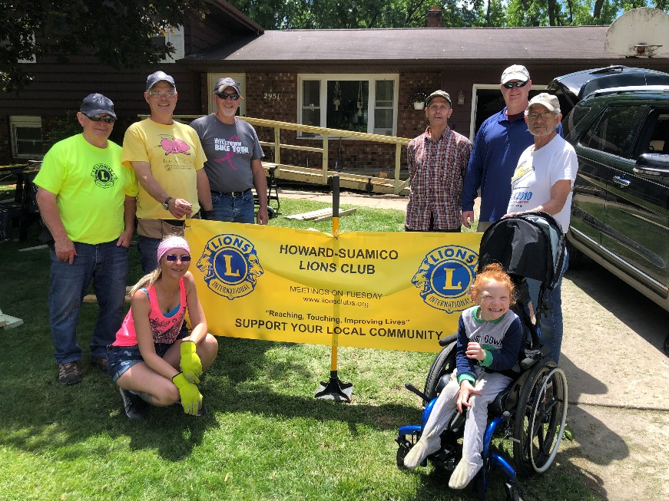

Recreation Updates

Adaptive Sports - We Need Your Input Please!

If you are a person with a disability and interested in participating in adaptive sporting opportunities such as wheelchair softball, basketball, or bowling, please let us know. We are collaborating with other state and national organizations, along with individuals to try to provide local opportunities for these and other sports, but would appreciate input from our community on what people are interested in. Please contact Calvin at (920)393-1037 or calvinr@optionsil.org if you would like to provide input on, participate in, learn about, or volunteer to assist with adaptive sports.

Tech Closet News
Options AT Specialist can assess an individual with a disability to determine the role assistive technology can play in achieving greater independence. For more information on the pictured technology or other assistive technology that can help you reach your goal of independence, contact Calvin Richtig, Options AT Specialist, at 920-393-1037 or toll-free at 888-465-1515, ext.130. (Assistive technology partially supported by the WisTech, Assistive Technology Program. Telecommunication partially funded by the Universal Service Fund (USF)).
Firefly 2.5 Electric Scooter Attachment
One of our newest pieces of assistive technology is a Firefly wheelchair accessory. This device attaches to the front of most manual wheelchairs to provide a battery power driven motor that will allow the user to go further and faster than by manually propelling. The device turns the front of your wheelchair into a scooter with a hand throttle and brakes. It can run up to 18 miles per hour, with different speeds that allow you to restrict speeds at lower levels. On a full charge, the firefly will run for up to 16 miles depending on usage and conditions. The firefly is available for you to use as a demonstration trial if you have considered purchasing one and want to know if it works for you, or you can check it out and use it for up to two weeks just to have some fun and see how it helps you get around, indoors or out. Contact Calvin at (920)393-1037 or calvinr@optionsil.org to learn more. Pictured is Autumn with the Firefly device attached to the front of her manual wheelchair riding on the road.

Options for Independent Living - Adaptive Adventures
By Calvin Richtig

Options for Independent Living has been searching for an opportunity to expand our assistive technology program and continuously re-energize our organization. Over the past few years, we have explored the community interest in adaptive recreation and found it to be an area of great interest due to a lack of opportunity and awareness for people with disabilities.

A few years ago, we partnered with Access Wisconsin whcich allowed us to provide people with disabilities in our community with access to an Action Trackchair. This gave us the opportunity to promote not only the chair, but access to recreational activities. Our relationship with WI AT program, WisTech, provided us the information to apply for and receive a grant through the Christopher and Dana Reeve Foundation. We used the grant funding to purchase an adaptive recumbent trike and transport trailer. This new piece of equipment provides an opportunity for individuals to bike who may not be able to use a standard or recumbent bicycle.

Our program continues to partner with other state and national organizations with the intent to grow sports programs including wheelchair basketball, softball, and bowling. Currently these programs are only available two to four hours away from our service area, a trip that several individuals make one to three times a week to be able to participate in team sports. Our relationships with these organizations and individuals have been pivotal in giving us resources to create new recreational programs in the future.

So far, we have been able to provide on average five to ten people each month with the use of adaptive equipment that has allowed them specifically to access recreational opportunities that they were unable to previously. One youth has been able to attend Boy Scout retreats, camping trips and five-mile hikes with his troop. Another individual was able to bike over ten miles around the lake that he has lived on for fifteen years but has never exceeded two miles using his standard recumbent trike. Another individual has explored forests and trails that he hadn’t been able to access in twenty years since the passing of his wife, which provided him with so many smiles and happy tears that he opted to purchase his own trackchair.

Another individual, who is a paraplegic, shared his story about developing a new routine using a Firefly on his manual wheelchair to ride ten miles alongside his teenage son while he bikes several times a week. Another individual left a note on a survey form at an adaptive recreation event that we participated in saying, “What a wonderful treat to get outdoors since my condition developed. Much of my current challenge is to be out among others due to acceptance issues. This weekend has just filled my heart with love.”

The ability to connect people with recreational adaptive equipment, events, and other people with shared lived experiences has been an incredible addition to our organization and we are excited for each new day that presents more opportunities to people with disabilities to recreate in our communities.
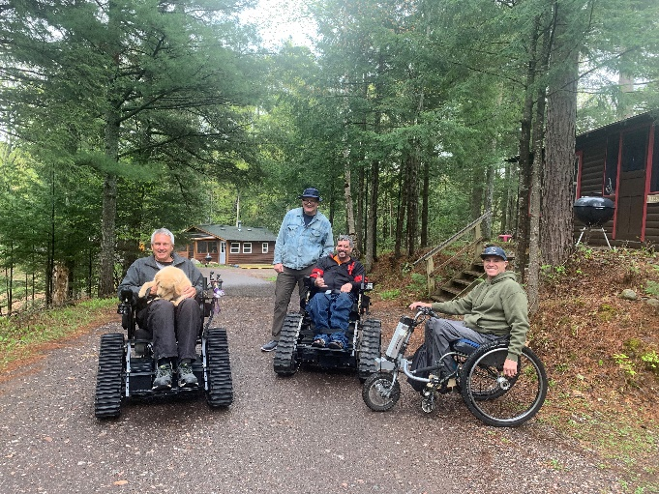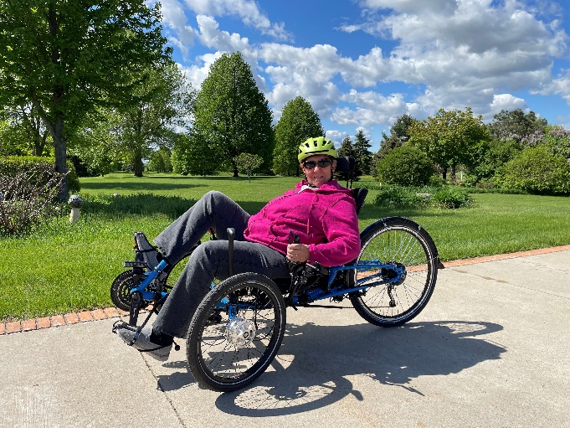

Northern Adventures Recap

By Calvin Richtig, ATP

In May I was given the opportunity to participate in an awesome event, Northern Adventures, held at the beautiful, accessible, Pine Forest Lodge on Spider Lake in Mercer, Wisconsin. This is a low-cost event put on by Adaptive Sportsmen and open for any members to join. The event provides great opportunities for participants to ride ATV trails, go fishing, pontoon rides, hiking, and biking. Most importantly it provides participants the ability to network, share stories, build camaraderie, and bond life-long friendships. I experienced the greatest display of peer support in my tenure with Options.

Participants ranged from people with disabilities, to able-bodied helpers, spouses, children, and friends. While part of the group took off for their 114-mile trail ride, the others remained at the lodge where we were able to hike the trails across the beautiful lakeside property. Options was able to collaborate with Access Ability Wisconsin to provide two Action Track Wheelchairs for the event, so anyone who was unable to walk or use their own wheelchair were able to gain access to the trails. Several participants had never been in such a device and were able to experience trails they have not accessed since prior to acquiring their disability. Options also brought our accessible recumbent trike purchased with a grant provided by the Christopher and Dana Reeve Foundation. The trike provided several individuals the ability to bike further than they have been able to before.

During the event I was given the opportunity to talk with everyone. We talked about accessibility and how adaptive sports and recreation equipment helped them achieve goals they couldn’t have any other way, and how these experiences changed their lives. Also, how the support of other participants helped them grow more independent. It taught family members to back off and let their loved ones learn the hard way, a lesson that is very difficult for many to do, and often hampers growth. They talked about how great the experience has been for an able bodied fourteen-year-old who has attended the annual event since birth and how it has taught him to be such a great helper and advocate for his father and people with disabilities. I learned about how diet and lifestyle changes have made big impacts on people’s lives, and how relationship dynamics have changed because of the disability and how new ones have formed.
I met with the founder of a great organization called Spinecore Foundation whose mission is to inspire people to continue leading healthy, active, and adventurous lives through outdoor adaptive sports. I met with a board member for Wisconsin Adaptive Sports Association regarding potential partnership that would allow our center to provide adaptive sports opportunities in Northeast Wisconsin. I heard stories from several athletes who shared with me how the games are played including one wheelchair softball player who offered to provide a training clinic for new athletes who may want to get involved in the sport. And the veteran with a TBI who felt that the event filled a place in his heart as he struggles finding a place to fit in. I left the event not only with a ton of great new friendships / partnerships, but also a load of donated adaptive recreational equipment that will help our program grow. If you have an interest in joining this annual event, or the numerous other opportunities that exist across Wisconsin, please reach out and we’d be thrilled to connect you with details.
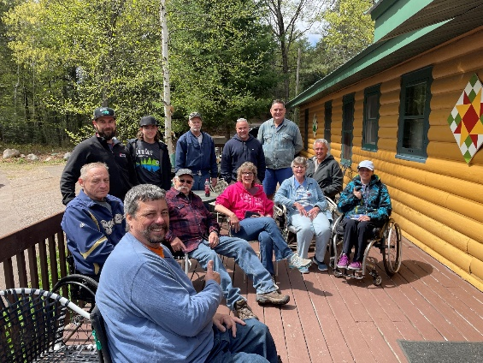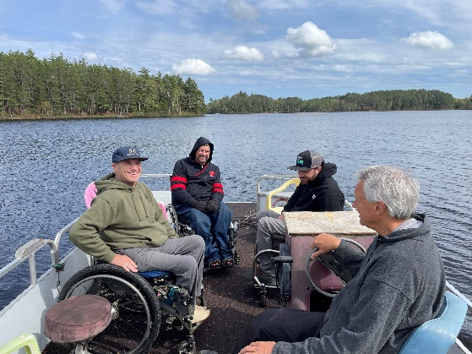

Do You Have Problems Hearing on Your Phone? The TEPP Program May be Able to Help!

What is TEPP? TEPP is the Telecommunications Equipment Purchase Program (TEPP), which helps people with disabilities buy equipment they need to use basic telephone services. The TEPP is paid for by the Wisconsin Universal Service Fund (USF) established by the Public Service Commission. Money is collected from Wisconsin telephone service providers to fund the USF. TEPP requires that an applicant: Be a Wisconsin resident; Be a person who is deaf, hard of hearing, speech impaired, or mobility or motion impaired; Need special equipment to use the telephone in the home or when traveling (like a TTY, amplification, visual alert system, etc.).

There is no age or income limit, but an individual can only get a TEPP voucher once every three years for the same type of disability. For more information on the TEPP program contact Calvin Richtig, Options AT Specialist at 920-393-1037.

Options has HOME funds for Home Accessibility, Rehabilitation, or Repair

The HOME Loan Program provides deferred payment/ no interest second mortgage loans to make homes accessible or make home repairs. The loans are focused on providing resources to households that include someone who has a disability or is older and is at low-to-moderate income status. Options receives funds for the HOME from the US Dept. of Housing and Urban Development through the State of Wisconsin Dept. of Administration, Division of Housing to administer the HOME Investment Partnership Program (HOME Loan Program).

The loan must be paid back when the property is sold, transferred, or ceases to be the borrower's principal place of residence. Types of projects include (but not limited to) ramp construction, bathroom, kitchen, and bedroom modifications, along with general housing rehabilitation and repairs.

The counties served by this program include Brown (outside Green Bay City limits), Calumet, Door, Fond du Lac, Green Lake, Kewaunee, Manitowoc, Marinette, Marquette, Menominee, Oconto, Outagamie, Shawano, Sheboygan, Waupaca, Waushara, and Winnebago Counties. Applicants must meet the eligibility requirements to be considered for a loan. For more information contact Steve LaFrombois at stevel@optionsil.org, 920-393-1044, or toll-free at 1-888-465-1515, ext. 122.

Consumer Spotlight on WisLoan

Paul needed a way to transport his power chair so he could go to doctor appointments, run errands, and socialize when he wanted. He filled out a WisLoan. application to purchase a small trailer, hitch installation on his vehicle, and accessories like a cover for the power chair, tie downs, etc. He was approved for the loan and is now able to get out and about independently. Paul recently sent us an email and picture expressing his gratitude.

“I would like to extend a note of thanks and gratitude to each of your companies' support, in helping me obtain my independence. You have no idea how the money has helped me in securing safe, effective transportation, while traveling to shop, spending time with my family and friends and just to become more mobile. I will forever be in your debt, for this ability to become a more free and mobile, disabled individual. Thank you, Options for Independent Living, Stacy Swaer, CP Inc., and the Wisloan Program, Laurie Lane, and Diane Mancl. Thank you all, for making my dreams a reality. Thank you all, for the work and effort you people have done, to change my life in such a profound way.” Paul is pictured, wearing a brown t-shirt, black shorts, and shoes. He is standing next to the trailer with his power chair on the trailer.
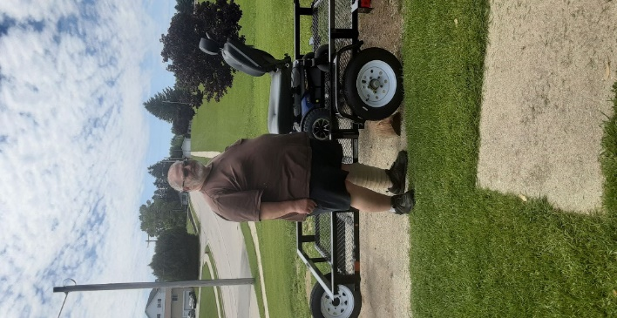

Wisconsin WisLoan Program

WisLoan is a statewide alternative loan program helping Wisconsin residents with a disability purchase assistive technology that assists them in living more independently and productively. Any Wisconsin resident with a disability over the age of 18 in need of assistive technology or home modifications is eligible to apply for a loan. Some examples of assistive technology include wheelchairs, hearing aids, Closed Circuit Televisions (CCTV’s), and vehicles with modifications, or the modifications necessary to make a vehicle accessible. For more information or to apply for WisLoan call Options at 920-490-0500 or toll-free at 1-888-465-1515. WisLoan is a federally-funded project of the National Institute for Disability and Rehabilitation, and a cooperative service of the Wisconsin Dept. of Health Services, IndependenceFirst, and BMO Harris Bank.

Telework Loan Program

The Wisconsin Telework program is a statewide, alternative loan program that allows Wisconsin residents with disabilities to purchase computers and other equipment needed to work from home or from other remotes sites, e.g., work on the road or at a telework center. Loan funds can be used to purchase equipment, training to use equipment, extended warranties, and cost of maintenance and repairs. For more information, contact the staff at Options for Independent Living at 920-490-0500 or toll-free at 1-888-465-1515.

This program is made possible through a grant from Rehabilitative Services Administration and authorized by Section (303) b of the Rehabilitation Act of 1973, as amended, and implemented by subsequent program regulation 34 C F R Part 373. The Department of Workforce Development-Division of Rehabilitation received the grant and provides programmatic and fiscal oversight. IndependenceFirst, a community based and consumer-controlled independent living center based in Milwaukee, administers the program in partnership with BMO Harris Bank and Wisconsin Independent Living Centers.

Volunteer Spotlight

Sue - I got seriously interested in volunteering at Options for Independent Living in response to one of the Facebook posts related to newly acquired assistive technology to address client's independence with respect to recreation. As a retired occupational therapist, I had a general awareness of service offered by Options for Independent Living, as well as services provided to individuals with disabilities through other Fox Valley agencies. I was particularly excited to see this focus on building independence around recreation - an important area that seems to receive less attention.

Volunteering at Options has been a wonderful experience! I particularly enjoy interacting with the staff (what a fun, caring, and knowledgeable crew) and with consumers who come in to borrow equipment from LEND.
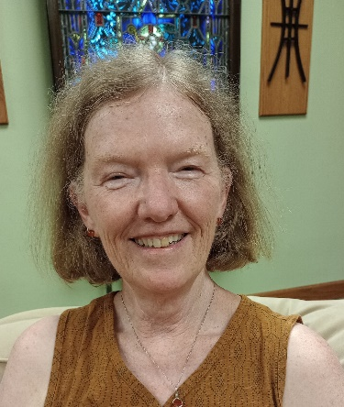

WANTED: Volunteers!! Make A Difference!

Options is looking for a few volunteers to help with the cleaning and light maintenance of our durable medical equipment used for our LEND program and for garden care. Options receives used durable medical equipment like walkers, wheelchairs, commodes, bath benches, etc., that need to be cleaned and tagged before being distributed to those who need it in our community. In addition, Options accessible garden needs assistance with weed pulling/maintenance. Work a couple hours a week or a couple of days. Become an Options volunteer and make a difference! If you are interested, please contact Josh at 920-393-1045.

Want to Get Involved in Legislative Advocacy? It’s easy, join Act Now!

Do you want your voice to be heard, but feel your voice alone would not be enough? Join Options legislative advocacy network, Act Now! Individuals in the network receive legislative alerts and updates on issues impacting people with disabilities. When an alert or update is received, everyone on the network is encouraged to pursue the issue by contacting their area legislators, therefore combining your voice with many! Act Now alerts can be delivered either through email or US Postal Mail. If you are interested in joining Act Now, contact Sandy Popp at Options (920) 393-1043 or toll-free at (888) 465-1515, ext.179.

Support Options on Amazon Smile
AmazonSmile is a program that donates 0.5% of your eligible purchases on Amazon to a charity of your choice. The process is easy. All you need to do is start you shopping at smile.amazon.com. and choose Options as the charity of your choice. The donation is made at no cost to you. It can also be used in the Amazon shopping app once activated. So, shop and support Options at the same time. Options thanks you!

MISSION STATEMENT: Options for Independent Living, serving people with disabilities in 17 counties of Northeast Wisconsin, is the pre-eminent non-profit organization of choice to empower people with disabilities. Options provides opportunities, through advocacy and education, for individuals with all disabilities and ages, to actively access their communities, maximize their independence, and connect with the resources and funding available to them.

Options website is: www.optionsil.org. Facebook is: https://www.facebook.com/optionsil.greenbay/

STAFF DIRECTORY

Executive Director Josh Theis (920)393-1045 josht@optionsil.org

Assistant Director Sandy Popp (920) 393-1043 sandyp@optionsil.org

Accountant Peggy Maas (920) 490-8270 peggym@optionsil.org

Administrative Assistant Missie Olm (920) 393-1052 missieo@optionsil.org

Rehabilitation Technology Specialist/Home Program Coordinator Steve LaFrombois (920)393-1044 stevel@optionsil.org

Accessibility Assessment Specialist Sarah Dunks (920) 393-1034 sarahd@optionsil.org

Accessibility Assessment Specialist Marie Smith (920) 393-1046 maries@optionsil.org

Work Incentives Benefits Specialist Karin Zuleger (920) 393-1039 karinz@optionsil.org

Assistive Technology Specialist Calvin Richtig (920) 393-1037 calvinr@optionsil.org

Assistive Technology Specialist Ian Kaster (920) 393-1053 iank@optionsil.org

Independent Living Coordinator Supervisor/Memory Loss Technology Specialist Stacie Scheibe (920) 393-1050 stacies@optionsil.org

Supportive Home Care Program Director/Personal Assistant Services Valerie Tschampl (920) 393-1036 valeriet@optionsil.org

PAS Program Care Coordinator Jennifer Lardinois (920)393-1032 jenniferl@optionsil.org

Secretary Barb Guyes (920) 490-0500 barbg@optionsil.org

Certified Peer Specialist Dave Zanon (920) 609-9467 davez@optionsil.org

Fox Valley Office—Appleton - 2331 E. Lourdes Drive

Independent Living Coordinator Brian Miller (920) 393-1038 brianm@optionsil.org

Board of Directors - Autumn Nordall – President, Connie Greenawald – Vice President, Jacob Ruatti-Treasurer, Lynn Smits, Scott Anderson, Eric Stream, Scott Menzel, Steve Boney.ounties served: Brown, Calumet, Door, Fond du Lac, Green Lake, Kewaunee, Manitowoc, Marinette, Marquette, Menominee, Oconto, Outagamie, Shawano, Sheboygan, Waupaca, Waushara, Winnebago

