# Independent Living Days at the Capitol

Independent Living Centers across the state converged on the State Capitol on February 21st to speak to their legislators about issues directly affecting people with disabilities throughout Wisconsin.

Independent Living Centers make this trip every year. There are eight Independent Living Centers that cover all 72 counties. Each center visited the Senators and Assembly persons that represented their service area. Therefore; all 132 legislators or staff were visited within just a few hours!

Thank you to *Options’* staff members John Meisner and Sandy Popp for their efforts in coordinating the event, as well as Wisconsin Coalition for Independent Living Center Executive Director Maureen Ryan.

Issues discussed were personal care worker compensation, transportation funding and pooling, Medicaid expansion, and an increase of funding for Independent Living Centers in Wisconsin, which have not received a raise in over 20 years. All of those mentioned were items Independent Living Centers have advocated for over the past years. It shows how vital it is to speak up and advocate.

# Consumer Corner-Stacy Ellingen

The following was posted by Stacy Ellingen after attending Independent Living Days in February. You can follow Stacy through her blog at <http://sdnetworkwi.org/stacy-ellingen>.

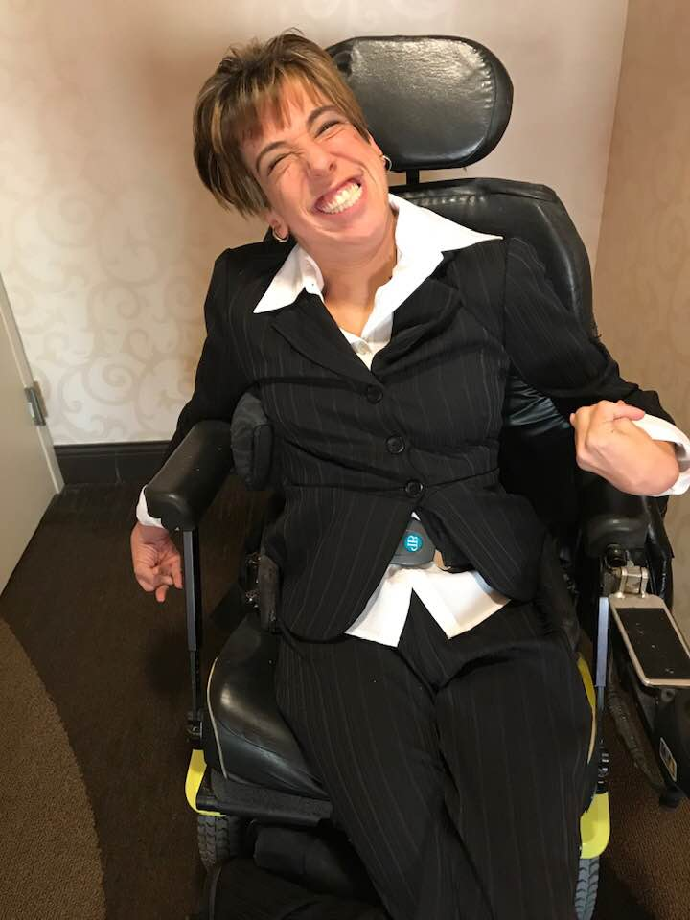

Have you ever been somewhere when you suddenly pause for a moment and think to yourself, “How did I get here?” Many times, those moments can feel like an epiphany to people. I had one of those moments in February while attending Independent Living Days in Madison.

Being a member of the Independent Living Council of Wisconsin, I was in Madison for four nights. Monday was our council meeting, Tuesday was an off day (the directors of the Centers had their meeting), and Wednesday and Thursday were Independent Living Days which is a two-day event- the first day is like a conference about Independent Living and the second day is meeting with legislators at the Capitol. There was a teleconference beforehand about what messages and asks to bring to the legislators. After the teleconference, I programmed all sorts of different things to say into my communication app.

Wednesday, they started the conference off by giving a brief history of Independent Living in Wisconsin. Being relatively new to this, I found it very interesting. The break-out sessions were more geared toward Independent Living Center staff, but it was great learning more about the services the Centers provide. For me, it was absolutely awesome getting to network with so many people—especially people from my area. Thursday morning, we met at the Capitol bright and early. People went in groups to each visit. There were four main topics we were supposed to discuss, but, as I learned, it was more important to explain to the legislators about what people with disabilities are struggling with and how more funding or supporting a certain bill or issue would help. During the visits, I often chimed in on the topic of healthcare sharing personal stories about the direct careworker shortage since that’s very prevalent in my life. I feel like personal stories make most of an impact on people.

After we were finished with our visits, we all met back in a huge courtroom to have lunch. As I was conversing with some of my new friends, I had *that* moment. How did I end up in the Capitol advocating for issues I wholeheartedly believe in? How did I become such an advocate? Twenty-five years ago, who would have ever thought that I’d be using my cell phone to not only converse with friends, but to speak with legislators about crucial issues people with disabilities face? I couldn’t help but reflect on where life’s path has taken me. Sure, there have been many curves, but, often, those curves lead me on new paths.

I can only hope we made an impact during our legislative visits that day. For me, saying it was an eye-opening experience would be a huge understatement. Being able to advocate on that level was truly amazing.

[Read Stacy’s full blog](http://sdnetworkwi.org/stacy-ellingen/blog/954/stacys-journal-life-changing-moments)

# Want to Get Involved in Legislative Advocacy? Join Act Now!

Do you want your voice heard, but feel just your voice alone would not be enough? Join *Options* legislative advocacy network, **Act Now!** Individuals in the network receive legislative alerts and updates on issues impacting people with disabilities. When an alert or update is received, everyone on the network is encouraged to pursue the issue by contacting their area legislators, combining your voice with many! Act Now alerts can be delivered either through email or US Postal Mail.

Contacting your legislators about issues that may affect you, or someone you know, is important. Your legislators want to hear firsthand how legislation being considered can impact your life positively or negatively. It helps in their decision making. Joining **Act Now** will assist you in those efforts. This network will educate you on the issues and help you to advocate more effectively. The more people in the network, the greater the impact.

If you are interested in joining Act Now, contact Sandy Popp at *Options* (920) 393-1043 or toll-free at (888) 465-1515, ext.179.

# Congratulations and Thank You, Kitty Barry!

Kathryn (Kitty) Barry was selected as this year’s recipient of *Options’* “Relentless Badger Award.” Kitty has been with *Options* for 38 years, and has recently retired as its Assistant Director.

Each of the eight Wisconsin Independent Living Centers selects a recipient of the Relentless Badger Award, which is presented at Independent Living Days in Madison. The award is given to staff, consumers, or allies who have been “relentless” in their advocacy efforts for and with people with disabilities.

In her nomination, Kitty was described as “someone who is caring, compassionate, and continuously working to better the lives of people with disabilities in Wisconsin. She has been a consummate advocate and although she does not have a disability, Kitty is respected not only by her co-workers and *Options’* Board of Directors, but by the people with disabilities she works with and for. She has been a mentor to most and an advocate for all!”

Executive Director Sue Premo observed, “Kitty has been an incredibly intelligent, patient, compassionate, and gracious leader within *Options*, the communities that we serve, and the State of Wisconsin. Our organization has been strengthened and the lives of those we serve are better because of Kitty Barry.”

Thank you, Kitty for all that you have given to the Independent Living Movement. Congratulations on a career well-lived, and we wish you all the best in your retirement adventure!

# Photo of Options staff standing around Kitty Barry after receiving her Relentless Badger award. Pictured in back from left to right are Steve LaFrombois, Stacie Scheibe, Calvin Richtig, Alyson Windle, Karin Zuleger, LeAnne Loveless, Marie Smith, Sandy Popp and Sue Premo. Front row from left to right is Stacy Ellingen, Joyce David, Kitty Barry, and Stephanie Birmingham. Benefits

**2019 SOCIAL SECURITY CHANGES**

**Cost-of-Living Adjustment (COLA):**

There will be a **2.8% COLA for 2019**. This means Social Security and Supplemental Security Income (SSI) benefits will increase 2.8% starting in January 2019. The following charts show some of the other Social Security changes for 2019.

|  |  |  |
| --- | --- | --- |
| **Social Security Disability Insurance (SSDI) Thresholds** | | |
|  | **2018** | **2019** |
| **Substantial Gainful Activity (SGA)** |  |  |
| **Non-Blind** | **$1,180.00/month** | **$1,220.00/month** |
| **Blind** | **$1,970.00/month** | **$2,040.00/month** |
| **Trial Work Period** | **$850.00/month** | **$880.00/month** |

|  |  |  |
| --- | --- | --- |
| **Supplemental Security Income (SSI) Thresholds** | | |
|  | **2018** | **2019** |
| **SSI Federal Benefit Rate** |  |  |
| **Individual** | **$750.00/month** | **$771.00/month** |
| **Couple** | **$1,125.00/month** | **$1,157.00/month** |
| **SSI Resource Limits** |  |  |
| **Individual** | **$2,000.00/month** | **$2,000.00/month** |
| **Couple** | **$3,000.00/month** | **$3,000.00/month** |
| **SSI Student Exclusion** |  |  |
| **Monthly Limit** | **1,820.00** | **$1,870.00** |
| **Annual Limit** | **$7,350.00** | **$7,550.00** |

This information is from the Social Security’s Fact Sheet on the 2019 Changes. You can view the Fact Sheet at <https://www.ssa.gov/news/press/factsheets/colafacts2019.pdf>. You can also find information on the 2019 COLA on Social Security’s website at <https://www.ssa.gov/news/press/releases/2018/#10-2018-1>.

# Tech Closet News

*Options* AT Specialist can assess an individual with a disability to determine the role assistive technology can play in achieving greater independence. For more information on the pictured technology or other assistive technology that can help you reach your goal of independence, contact Calvin Richtig, *Options* AT Specialist, at 920-393-1037 or toll-free at 888-465-1515, ext.130. (*Assistive technology* p*artially supported by the WisTech, Assistive Technology Program. Telecommunication partially funded by the Universal Service Fund (USF))*. Image of Wistech Assistive Technology Program Logo

## Liftware

There are several types of adaptive utensils available for individuals who struggle with using standard eating utensils independently. There are also modifications that can be made to existing utensils.

Liftware has created an interchangeable utensil called Liftware Steady.  The Steady was created to minimize the effects of hand/arm tremors.  This device uses electronic technology to counteract tremors, reducing the shake of the utensil by up to 70%.

Another product by Liftware is called the Level.  This utensil is intended for individuals with limited range of motion or have difficulty bending their wrist.  The head of the utensil bends as it moves to stay horizontal allowing for easier self-feeding.  It also has an optional cuff that allows it to attach to the user’s hand for those with limited grip strength.

These Liftware utensils have interchangeable heads allowing for an easy switch from fork to spoon.  Both are available for demonstration at our showcase model home.

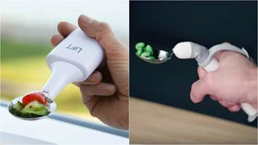

# Talking Watch

*Options* has talking watches available for demonstration.  For individuals with vision loss, memory loss, or who struggle using a watch for other reasons these watches can provide a simple solution.  There are several ways to assist with this barrier, but for many a talking watch provides an easy, reliable solution that requires minimal training.  Some watches can be programed to vocalize the time automatically at certain intervals, and all can be activated by pressing a button.  Like most watches, the bands are generally interchangeable, allowing individuals many fashion choices, possibly even using an existing band.  There is a range of male and female voices available for people who have preferences and the volume can be set to accommodate users who have mild hearing loss.



## Recreation

There are many great outdoor recreational opportunities available in Wisconsin. The Wisconsin Department of Natural Resources offer many of these opportunities including access to adaptive kayaks and boat launches, beach wheelchairs, accessible cabins, sit skis, accessible docks, piers and fishing sites, and access to miles of accessible trails.

**Adaptive kayaks** are available at Buckhorn, Council Grounds, Devil’s Lake, Mirror Lake and Perrot state parks.

**Beach wheelchairs and/or beach access** mats are available at Big Bay, Buckhorn, Harrington Beach, Kohler-Andrae and Whitefish Dunes state parks.

**Accessible cabins** are available by reservation at Copper Falls, Blue Mound, Mirror Lake, Buckhorn, High Cliff, Kohler-Andrae state parks, Kettle Moraine state forest southern unit and Richard Bong state recreation area.

It’s recommended that you contact the state park you plan to visit prior to your trip to be sure that the equipment is available. *Options* is working with the Department of Natural Resources to get a more expansive list of accessible recreational opportunities. You can learn more about these opportunities by visiting the “Open the Outdoors” page on their website, at <https://dnr.wi.gov/topic/openoutdoors/> or calling DNR accessibility coordinator, Nick Zouski, at 608-267-7490.

beach wheelchair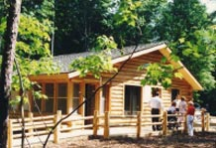

# Accessible Lodges, Resorts, Bed and Breakfasts, and Tour Company for Year Round Fun!

**Pine Forest Lodge,** Mercer, WI (715) 476-2241 http://www.pineforestlodge.com/index.htm or https://pineforestlodge.com/about-us/

**Sunrise Lodge, Land O’Lakes, WI** (800) 221-9689, (715) 547-3684, [www.sunriselodge.com](http://www.sunriselodge.com/)

**Sunset Pines Resort, Willard WI** (715) 267– 8969, www.sunsetpinesresort.com

**Accessible Bed and Breakfasts**

**Welcome HOME,** Newburg WI (near Cedarburg) For information or reservations: Call (262) 675-2525 or www.welcomehomebb.co

**The Feathered Star,** Egg Harbor (2 rooms have roll-in showers) For information or reservations: Call toll-free (877) 743-4066 or [www.featheredstar.com](http://www.featheredstar.com/)

**Accessible Travel Tour Company**

**Abel Trek,** Reedsville WI (800) 205-6173 or https://abletrektours.com/

Please note, *Options’* staff have toured the Bed and Breakfast’s listed and they are very accessible for individuals who use wheelchairs. We have not toured the resorts or lodges nor have we worked with this travel planner. It is best to call and make sure the type of access you may require will be provided.

# Action Trackchair

Options for Independent Living is teaming up with Access Ability Wisconsin (AAW) in an effort to be a host site for an Action Trackchair. This partnership provides a great opportunity for individuals with limited mobility to explore outdoor areas that were previously inaccessible to them. AAW's objective is to provide recreational opportunities for people with physical challenges who want to enjoy the Wisconsin outdoors.

An Action Trackchair is an all-terrain mobility device that uses tank style tracks instead of wheels in order to provide extreme traction, durability, and balance. It allows people to access places that a standard mobility device could never go.

The Trackchair will be available for individuals to loan for approximately two weeks at a time. Individuals interested must have a sufficient tow vehicle and storage location for the chair during usage. Users will be asked to undergo training prior to checkout and complete a survey and submit photos after. There will not be a charge to utilize the device, but a $50.00 refundable deposit will be required.

You can contact Calvin at *Options* for more information if you are interested in this great opportunity that AAW has allowed us to provide for our consumers. You can visit their website at [www.accessabilitywi.org](http://www.accessabilitywi.org) to learn more about their organization or to request a reservation. Anticipated availability is May 15. More detailed directions about the reservation process will follow in upcoming newsletters and on our Facebook page.



# Emergency Preparedness

An emergency that requires you to evacuate your home can happen at any time and you may only have a couple minutes to get out.  Contact *Options* to receive the “Emergency Preparedness Toolkit for Persons with Disabilities” to be prepared. Developed by the Wisconsin Council on Physical Disabilities and the Wisconsin Association of the Deaf, the toolkit serves as a resource tool providing all people, particularly those individuals with disabilities, emergency preparedness information. It includes tips, checklists, a wallet card, visual communications tool, and other resources to be prepared and have a plan for emergencies and natural disasters.

The Emergency Preparedness Toolkit includes information about evacuation and escape planning, including procedures and devices. It also includes a bag that can be grabbed quickly and outfitted to include items like medications, adaptive equipment, important paperwork, etc.

You can pick-up a bag through *Options*, or order one online, please visit <https://cpd.wisconsin.gov/toolkit.htm>.

If you would like more information on the Emergency Preparedness Toolkit you can call John Meissner at (920) 997-9999.

# Are you ready to be a homeowner?

Have you been thinking about buying a home? Join us on Tuesday, June 18th, 2019 from 11:00 am to 12:30 p.m. at the Aging and Disability Resource Center in Green Bay. The Aging and Disability Resource Center is located at 300 South Adams Street in Green Bay.

Join us to discuss:

1. Is Homeownership right for you?
2. What it really costs each month to live in a home
3. The steps to buying a home
4. Supports available to help with the home buying process
5. Supports available if you have a disability

Take this opportunity to ask the experts the questions you’ve been thinking about. Our panel of experts includes Michael Howard, a local Shorewest Realtor, Eileen Gossen from NeighborWorks of Green Bay, Sue Premo from Options for Independent Living, and Anna Zahorik, an ADRC Information and Assistance Specialist.

Please call the Aging and Disability Resource Center at (920) 448-4300 to register.

# *Options* has HOME funds for Home Accessibility, Rehabilitation, or Repair

The HOME Loan Program provides deferred payment/ no interest second mortgage loans to make homes accessible or make home repairs. The loans are focused on providing resources to households that include someone who has a disability or is older and is at low-to-moderate income status.

*Options* receives funds for the HOME from the US Dept. of Housing and Urban Development through the State of Wisconsin Dept. of Administration, Division of Housing to administer the HOME Investment Partnership Program (HOME Loan Program).

The loan must be paid back when the property is sold, transferred or ceases to be the borrower's principal place of residence.

Types of projects include (but not limited to) ramp construction, bathroom, kitchen and bedroom modifications, along with general housing rehabilitation and repairs. The counties served by this program include Brown (outside Green Bay City limits), Calumet, Door, Fond du Lac, Green Lake, Kewaunee, Manitowoc, Marinette, Marquette, Menominee, Oconto, Outagamie, Shawano, Sheboygan, Waupaca, Waushara, and Winnebago Counties. Applicants must meet the eligibility requirements to be considered for a loan.

For more information contact Steve LaFrombois at [stevel@optionsil.org](mailto:stevel@optionsil.org), 920-393-1044, or toll-free at 1-888-465-1515, ext. 122.

# Options’ Medicaid Personal Care Program

*Options* offers a Personal Care Program for people with permanent physical disabilities who are: Medicaid beneficiaries, medically stable, require personal care services, and have identified an individual to provide personal care.

The program is consumer-directed and includes personal care assistance with: bathing, dressing/undressing, prosthetics, grooming, eating, mobility in home, toileting, transferring, and incidental services (laundry, light housekeeping, meal prep).

The consumer must agree to responsibly use personal care services and have back-up support available as needed. *Options* does not provide emergency or back-up personal care services.

Consumers utilizing *Options* Personal Care Program must have chosen an individual who they are interested in hiring. The Personal Care Worker (PCW) candidate must be at least 18 years-old and be trained in the skill(s) necessary to provide cares to the consumer. The PCW cannot be a parent/guardian of a minor child or a spouse.

If you have a referral or would like more information on *Options* Personal Care Program please contact Valerie Tschampl, RN Supervisor at 920-393-1036 or toll-free at 888-465-1515, ext. 182 or e-mail at [valeriet@optionsil.org](mailto:valeriet@optionsil.org).

# Wisconsin WisLoan Program

WisLoan is a statewide alternative loan program helping Wisconsin residents with a disability purchase assistive technology that assists them in living more independently and productively. Any Wisconsin resident with a disability over the age of 18 in need of assistive technology or home modifications is eligible to apply for a loan.

Some examples of assistive technology include wheelchairs, hearing aids, Closed Circuit Televisions (CCTV’s), and vehicles with modifications, or the modifications necessary to make a vehicle accessible. In addition, loans have been approved for home modifications such as ramp construction and roll-in showers. Loan amounts range from $500.00 to $50,000.00, but the actual loan amount will depend on the items purchased and ability to repay.

Current interest rate on a WisLoan is 6.5%. If you have bad credit, including bankruptcy, your application will still be considered. The focus is on the ability to make monthly payments to repay the loan. For more information or to apply for WisLoan call *Options* at 920-490-0500 or toll-free at 1-888-465-1515.

*WisLoan is a federally-funded project of the National Institute for Disability and Rehabilitation, and a cooperative service of the Wisconsin Dept. of Health Services, IndependenceFirst, and BMO Harris Bank.*

# Telework Loan Program

The Wisconsin Telework program is a statewide, alternative loan program that allows Wisconsin residents with disabilities to purchase computers and other equipment needed to work from home or from other remotes sites, e.g. work on the road or at a telework center. Loan funds can be used to purchase equipment, training to use equipment, extended warranties, and cost of maintenance and repairs.

You can apply for the amount you need, but actual loan amounts will depend on the item purchased and your ability to repay the loan. The interest rate is 6.5% and the term length depends on the amount of the loan and the item purchased. For more information contact the staff at *Options* for Independent Living at 920-490-0500 or toll-free at 1-888-465-1515.

*This program is made possible through a grant from Rehabilitative Services Administration and authorized by Section (303)b of the Rehabilitation Act of 1973, as amended and implemented by subsequent program regulation 34 C F R Part 373. The Department of Workforce Development-Division of Rehabilitation received the grant and provides programmatic and fiscal oversight. IndependenceFirst, a community based and consumer-controlled independent living center based in Milwaukee, administers the program in partnership with BMO Harris Bank and Wisconsin Independent Living Centers.*

## Support Groups Meeting at Options

*Options* for Independent Living hosts several support group meetings:

**CARE Café – “A place for adults on the spectrum.”** This is a social support group for adults 18 and over on the autism spectrum. Meetings are held the 2nd and 4th Friday from 6-8 pm at *Options*. The meetings are free. For more information, contact CARE Café on Facebook or email [mortongbay@aol.com](mailto:mortongbay@aol.com) or [jjmorton@spectrumblue.net](mailto:jjmorton@spectrumblue.net). You can also request that you be added to their email roster which will include updates on meeting plans and location, any meeting changes, etc.

**Epilepsy Support Group –** Meetings are held at *Options* every 3rd Tuesday of the month from 6:00—7:30 pm. For more information contact Kristien Dostal at 715-341-5811 or email him at [*kdostal@epilepsywisconsin.org*](mailto:kdostal@epilepsywisconsin.org).

**ALS Support Group -** Meetings are held the 2nd Wednesday of each month at *Options* from 6 pm—8 pm. For more information, contact Carolynne Younk, MS, Care Service Coordinator for ALS Association Wisconsin Chapter Satellite office in Green Bay. Contact number is 920-288-7095.

**The Adult Asperger Support Group**, of ASNEW- Autism Society of Northeast Wisconsin.  Meetings are held the first Monday of each month at *Options* from 6 pm—7:30 pm. For more information, email administrator@asnew.org or call 920-264-8067.

# CenterPoint is Green!

Help *Options* be environmentally friendly and reduce publication costs by signing up to receive the *CenterPoint* newsletter electronically! We mail out approximately 2,000 copies each time we publish *CenterPoint*. CenterPoint is now available in electronic form, PDF and Word text formats, through *Options’* website at [www.optionsil.org](http://www.optionsil.org). You can sign up to receive the newsletter via email by going to the *Options* Website Home page, scroll down and click the Newsletter Sign-up tab on the bottom left. Once you sign up, you will receive the newsletter via email with a PDF and a Word Text attachment. Then call us at 1-888-465-1515 to let us know you will be receiving the newsletter via electronic format and no longer want one mailed to you.

# *Options* Welcomes New Staff Members!

Things are changing and growing at Options! The following staff members have joined us since the fall edition of Centerpoint

 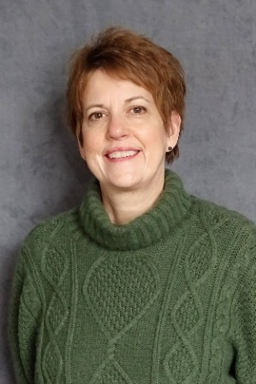

LeAnne Loveless Marie Smith

Independent Living Coordinator Accessibility Assessment Specialist

leannel@optionsil.org maries@optionsil.org

(920) 393-1047 (920) 393-1046

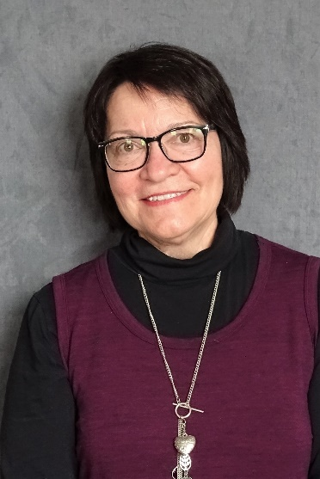 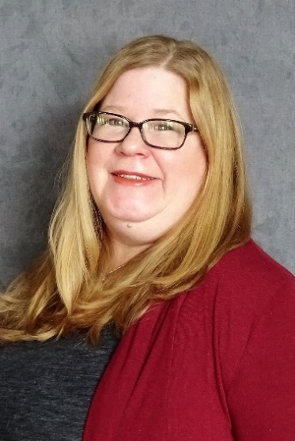

Valerie Tschampl Missie Olm

Director of Personal Care/Supportive Home Care Administrative Assistant

valeriet@optionsil.org missieo@optionsil.com

(920) 393-1036 (920) 393-1052

Options for Independent Living Inc. **VISION STATEMENT:** *Options*for Independent Living empowers people with disabilities.

**MISSION STATEMENT:** *Options* for Independent Living, serving people with disabilities in 17 counties of Northeast Wisconsin, is the pre-eminent non-profit organization of choice to empower people with disabilities. *Options* provides opportunities, through advocacy and education, for individuals with all disabilities and ages, to actively access their communities, maximize their independence, and connect with the resources and funding available to them.

**Main Office—Green Bay**

**555 Country Club Road**

Toll Free 1-888-465-1515

Fax 920-490-0700

# STAFF DIRECTORY

*Executive Director* Sue Premo (920)393-1045 [suep@optionsil.org](mailto:suep@optionsil.org)

*Accountant* Peggy Maas (920) 490-8270 [peggym@optionsil.org](mailto:peggym@optionsil.org)

*Administrative Assistant* Missie Olm (920) 393-1052 missieo@optionsil.org

*Rehabilitation Technology Specialist/Home Program Coordinator* Steve LaFrombois (920)393-1044 [*stevel@optionsil.org*](mailto:stevel@optionsil.org)

*Accessibility Assessment Specialist* Sarah Dunks(920) 393-1034[*sarahd@optionsil.org*](mailto:stevel@optionsil.org)

*Accessibility Assessment Specialist* Marie Smith(920) 393-1046 *maries@optionsil.org*

*Work Incentives Benefits Specialist* Karin Zuleger (920) 393-1039 [karinz@optionsil.org](mailto:karinz@optionsil.org)

*Director of Independent Living Sandra L. Popp* (920) 393-1043 [sandyp@optionsil.org](mailto:karinz@optionsil.org)

*Assistive Technology Specialist* Calvin Richtig (920) 393-1037 [calvinr@optionsil.org](mailto:karinz@optionsil.org)

*Independent Living Coord./Memory Loss Technology Specialist*  Stacie Scheibe (920) 393-1050 [stacies@optionsil.org](mailto:byiam@optionsil.org)

*Independent Living Coordinator* LeAnne Loveless(920) 393-1047 [leannel@optionsil.org](mailto:leannel@optionsil.org)

*Supportive Home Care Program Director/Personal Assistant Services* Valerie Tschampl (920) 393-1036 [valeriet@optionsil.org](mailto:valeriet@optionsil.org)

*RN Supervisor—PCA Program* Carol Hall Ext (920) 393-1032 [carolh@optionsil.org](mailto:karinz@optionsil.org)

*Billing Specialist—PCA Program* Annette Nitke (920) 393-1048 [annetten@optionsil.org](mailto:karinz@optionsil.org)

*Secretary* Barb Guyes(920) 490-0500 [barbg@optionsil.org](mailto:karinz@optionsil.org)

*Certified Peer Specialist* Dave Zanon (920) 609-9467 [davez@optionsil.org](mailto:davez@optionsil.org)

*Advocacy Coordinator* Stephanie Brimingham (920) 495-9688 stephanieb@optionsil.org

*Special Projects* Kathryn C. Barry [kittyb@optionsil.org](mailto:kittyb@optionsil.org)

**Fox Valley Office—Appleton - 2331 E. Lourdes Drive**

*Independent Living Coordinator* John Meissner - Appleton Office 920-997-9999 [johnm@optionsil.org](mailto:vickyl@optionsil.org)

*Independent Living Coordinator* Alyson Windle—Appleton Office 920-882-9309 [alysonw@optionsil.org](mailto:vickyl@optionsil.org)

**Board of Directors - Ann Jadin-**President **Autumn Nordall-** Vice President **Jacob Ruatti-T**reasurer **Joyce David-**Secretary

**Scott Anderson, Steve Boney, Connie Greenawald, Scott Menzel, Byia Martin, Joe Martin, Amy Perry, Lynn Smits**

**Counties served:** Brown, Calumet, Door, Fond du Lac, Green Lake, Kewaunee, Manitowoc, Marinette, Marquette, Menominee, Oconto, Outagamie, Shawano, Sheboygan, Waupaca, Waushara, Winnebago

*Options* website is: [www.optionsil.org](http://www.optionsil.org) Facebook is: <https://www.facebook.com/optionsil.greenbay/>